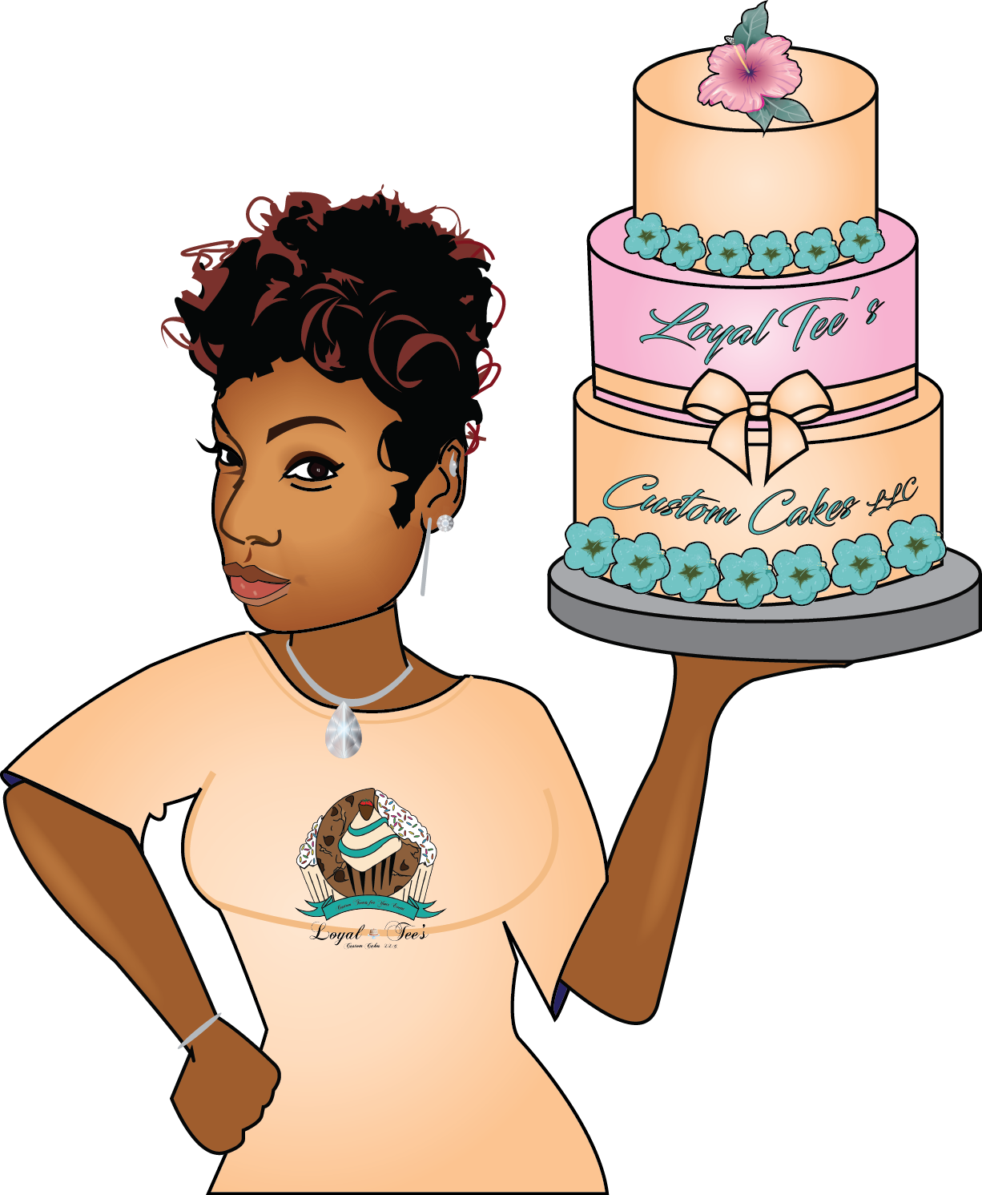
Loyal Tee’s Custom Cakes LLC Cake Contract

Name:___________________________________________________ Email__________________________________

Phone:_______________________ Date order is needed for___________ Time cake is needed by:_____am/pm

Delivery Address (if applicable) : __________________________________________________________________________
Type of cake (circle one): Wedding Birthday Gender Reveal Baby Shower Adult Anniversary Gag Other
Cake Flavor (circle one): Yellow Vanilla Chocolate Marble SpecialTee Flavor:___________________________

Cake Theme/Colors____________________________________________________________________________________

Wording/Name to be incorporated:_______________________________________________________________________

Please read each item below thoroughly & initial each line to be sure that you fully understand all the terms of this contract.
Ordering and Booking
- ____Once we have finalized the cake/cupcake design you want, I will issue out an online invoice via PayPal to your email address. This invoice can be paid with your PayPal account, Cash App, credit, or debit.
- ____A retainer payment of 50% of your order total is due to officially book your order. Dates fill fast and are first paid, first booked.
- ____Your retainer payment is not refundable.
- ____The remaining half of your order balance is due one week prior to delivery/pick up of your order. *Reminders will not be sent*
- ____Any orders under $100, total balance is due in full when order is placed.
- ____You have 24 hours to make full/retainer payment once invoice has been sent or invoice will be cancelled at which point quoted prices and date availability are no longer guaranteed.
- ____If order is canceled for any reason & invoice must be re-sent, a $10 fee will apply, and payment is due same day invoice is re-sent.
- ____If remaining balance isn't paid IN FULL by due date, order will be canceled. At which time deposit will be forfeited and all quoted prices and date availability become null & void.
- ____Any orders placed with less than a week's notice will have a 'last minute order fee" of $25-$100 applied. Fee depends on how many days before cake is needed.
- ____Any orders placed with less than a week's notice, total balance is due when order is placed.

Cake Details
- ____Cake orders will be made to specific directions to the best of Loyal Tee’s Custom Cakes LLC’s ability. Some reproductions will not be exact due to copy write infringements, sizes of cake, size difference between layers of cakes, differences in materials used, skills required, etc.
- ____ All food colors in buttercream, fondant, gum paste and modeling chocolate are unstable, difficult to match exactly and are hard to gauge from batch to batch and between different mediums (from buttercream to fondant or gum paste for example). In some cases, we require that you provide us with swatches for better matches and we will attempt to recreate a color to the best of our ability. However, because of the instability of food colors they very easily fade, change colors, bleed, blend in with other colors, as well as stain clothing, linens, skin and mouths. Colors are not guaranteed.
- ____ Certain parts of a tiered cake or certain cake decorations requested by The Cake Purchaser may contain food safe non-edible materials and care should be taken that no one consumes these items. Details on how to cut your cake and remove non-edible materials will be provided at the time of Delivery or Pickup.
- Loyal Tee’s Custom Cakes LLC will not be held liable from any injuries sustained from food safe, non-edible materials.
- ____ Cakes 3 tiers or larger that do not have a separating plate system may possibly be unstable easier to tip over. The plate system is extra.
- ____ Average heights of a single layer of tiered cakes are approximately 2.5 to 3 inches tall. Some sinking may occur, especially in the center of the cakes. This is due a number of factors, including but not limited to heating cores in cakes that help promote even baking. This is normal and does not affect the quality or taste of the cake.
- ____All cake ingredients, equipment or machinery comes into contact with peanuts, tree nuts or other common allergens. You agree to acknowledge this & notify your guests of this risk. Loyal Tee’s Custom Cakes LLC will be held harmless for allergic reactions.
- ____Optimal cake temperature is 70 degrees or lower. A cake sitting outdoors or exposed to the outdoors heat may melt, begin to distort and colors may fade. Loyal Tee’s Custom Cakes LLC will be held harmless for issues resulting in outdoor exposure of your cake.

Pickup and Delivery

- ____ I meet all customers at Trotwood YMCA, 506 E. Main St. Trotwood, Ohio 45426. Other areas will be determined by mileage and calculated at $0.85 per mile to AND from.
- ____ Delivery times are a range of time set based on your event time and other cakes order pickups for that day. The delivery may be made anytime within that range.
- ____Pick up times will be arranged with the customer and are a set time based on several factors and are usually arranged around delivery times for other orders that day. Please be prompt to pick up your cake at the time arranged. Failure to do so may result in a delay your ability to get your cake.
- ____ Cakes are incredibly fragile. Any damage made to the cake after pickup or after the completion of the delivery and setup, are the fault of the cake purchaser. A guide will be provided upon pickup or delivery on how to properly handle your cake. Loyal Tee’s Custom Cakes LLC will not be held liable for damages made to cakes after pickup or setup is complete.

Cancellation Policy

- ____ Loyal Tee’s Custom Cakes LLC requires at least one week’s notice for all cancellations.
- ____Cancellations on behalf of the cake purchaser will result in a refund of all money paid toward the order at current, minus the non-refundable retainer and for work already completed or supplies already purchased. Cancelled orders may be transferred to another date within a 6month period as long as it is currently available.
- ____ Cancellations on behalf of Loyal Tee’s Custom Cakes LLC for any reason will result in a refund of no more than the total money paid toward the order including the non-refundable retainer.

Refund Policy

- ____ In the event that an order is found unsuitable in any way that the cake purchaser requires a refund of the cake total, all cake must cease to be served and all cake that has been served must be collected at once. Loyal Tee’s Custom Cakes LLC and its owners must be called to collect the cake (local) or the cake must be returned in full IMMEDIATELY. It MUST NOT be eaten or discarded. If no cake is returned, no refund will be considered. An inspection will be performed to determine the validity of the claims before any partial or full refund is issued.

Sign at the time of booking

“As the Cake Purchaser, I have verified that all details contained in the order form are correct and have read these terms and agreed.”
Print: ____________________________________________________________
Sign: ________________________________________________________________Date: _____________

Sign Upon Pickup or Delivery
“As the Cake Purchaser, I agree that the order has been picked up and delivered, is intact and the order is satisfactory to my request” (this part may be completed by a person designated by The Cake Purchaser in writing).
Print: ____________________________________________________________
Sign: ________________________________________________________________Date: _____________

Revised: January 13, 2023

